**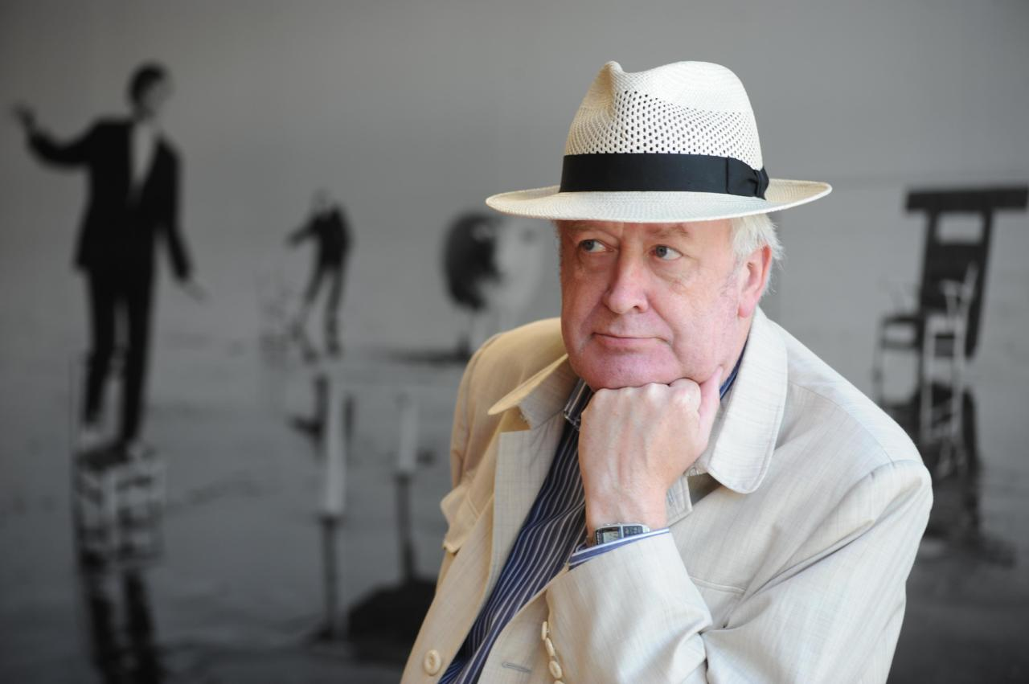**

**Hans von Storch** is a German climate scientist and has been counted among the 100 most influential Germans by the Focus magazine for being a "climate realist". He is a Professor at the Meteorological Institute of the University of Hamburg, and since 2001 Director of the Institute for Coastal Research at the Helmholtz Research Centre in Geesthacht, Germany. He is a member of the advisory boards of the journals Journal of Climate and Annals of Geophysics. Prof. von Storch has received the IMSC achievement award at the International Meetings on Statistical Climatology in Edinburgh in 2010 for key contributions to statistical downscaling, reconstruction of temperature series, analyses of climatic variability, and detection and attribution of climate change.

His keynote lecture “DETECTION AND ATTRIBUTION OF CLIMATE CHANGE IN THE BALTIC SEA REGION” will be as an opening one of the 10th BSSC on 16 June.

**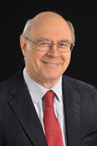**

**Michael Elliott** is aDirector of the Institute of Estuarine & Coastal Studies (IECS) ( <http://www.hull.ac.uk/iecs>) and Professor of Estuarine and Coastal Sciences at the University of Hull, UK. Professor Elliott is a marine biologist with a wide experience of biological and environmental analyses, but especially with interests in human impacts, marine and estuarine management and policy. His teaching, research, advisory and consultancy work has included studies of many ecological components and communities, as well as policy, governance and management of estuaries and coasts. He is one of the lead contributors to the FP7 project VECTORS <http://www.marine-vectors.eu/> focussing on creation of an effective cross-sector and cross-border marine governance and management. Prof. Elliott has published widely, co-authoring/co-editing 15 books and contributing to over 200 scientific publications. This includes co-authoring *'The Estuarine Ecosystem: ecology, threats and management'* (with DS McLusky, OUP, 2004), *'Ecology of Marine Sediments: science to management'* (with JS Gray, OUP, 2009) and as a volume editor and contributor to the *Treatise on Estuarine & Coastal Science*, Elsevier, Amsterdam (Eds.-In-Chief - E Wolanski & McLusky, DS). He has acted as an advisor on many environmental matters for academia, industry, government and statutory bodies in Europe and elsewhere. Prof. Elliott is a past-President of the international Estuarine & Coastal Sciences Association (ECSA) and is also one of the 4 Editors-in-Chief of the international journal *Estuarine, Coastal & Shelf Science*; he has Adjunct Professor and Research positions at Murdoch University (Perth), Klaipeda University (Lithuania), the University of Palermo (Italy), and the South African Institute for Aquatic Biodiversity, Grahamstown. From 2014 Appointed Independent Non-Executive member of the UK Marine Science Coordinating Committee and member of the Science Advisory Board of Marine Scotland. From 2014, member Society for Underwater Technology: International Salvage & Decommissioning Committee. Awarded Laureate of the Honorary Winberg Medal 2014 of the Russian Hydrobiological Academic Society.

His key-note lecture “IN SEARCH OF THE BEST CROSS‐BORDER AND ‐SECTOR GOVERNANCE MODEL**”** will be on 17 June in the frame of Policy Day session.

**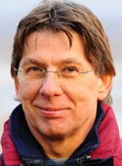 Rudolf De Groot** is anAssociate Professor in Integrated Ecosystem Assessment & Management with the Environmental Systems Analysis Group of Wageningen University, the Netherlands. De Groot is a world level authority on the concept of ecosystem services and their valuation. He published over 100 scientific papers, including 2 books, and was involved as Coordinating Lead author in the UN-supported Millennium Ecosystem Assessment (2001-2005) [www.maweb.org](http://www.maweb.org/" \t "_blank) and the global study on “The Economics of Ecosystems & Biodiversity” (TEEB 2008-2010)[www.teebweb.org](http://www.teebweb.org/" \t "_blank). Rudolf co-authored the classical study of 1997 “The value of the world’s ecosystem services and natural capital” (Nature, Vol. 387, May 1997) and its revisit in 2014 (Global Environmental Change Vol.26, May 2014). He has been a key note lecturer at several larger meetings including global conference on Ocean and coastal management, Shanghai, 2013 <http://www.estuarinecoastalconference.com/bio-degroot.html> . De Groot is a member of the Editorial Board of several Journals, including “Conservation Letters” and “Regional Environmental Change” and Editor-in-Chief of the International Journal on “Biodiversity Science, Ecosystem Services and Management” and co-founder and Topic Editor of the new Elsevier Journal “Ecosystem Services: Science, Policy & Practice”. He is Special Advisor on Ecosystem Services of the IUCN Commission on Ecosystem Management (CEM) and Chair of the Ecosystem Services Partnership ([www.es-partnership.org](http://www.es-partnership.org/" \t "_blank)).

At the 10th BSSC R. De Groot’s key-note talk “In a quest to embed marine goods and services to societal action in support of region’s prosperity“ will be a part of Policy Day on 17 June.

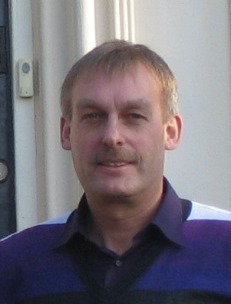

**Herman Hummel** is head of the Monitor Taskforce at the Royal Netherlands Institute for Sea Research, and professor in Estuarine Ecophysiology at the University of Gdansk, Poland. His specific aim is to understand the relation between fluctuations in environmental factors (salinity, tide, food, degree of pollution) and genetics, physiology and ecology (diversity, distribution, biomass, growth, condition, reproduction, reserve constituents) of estuarine macrobenthos. Herman has been (co-)leading several major international projects and concerted actions in the field of marine biodiversity. To this belonged the coordination of the EC Concerted Action BIOMARE (implementation and networking of large-scale long-term marine biodiversity research in Europe; with 24 participating European institutes), the BIOCOMBE project (on the degree and impact of changes in diversity of dominant marine benthic species on coastal ecosystems), the NoE MarBEF (Network of Excellence on Marine Biodiversity and Ecosystem Functioning; with 95 participating European institutes), and EMBOS (the European Marine Biodiversity Observatory System, with 22 participating European countries). In connection to these major projects, Herman is President of the MARS Network, a network uniting more than 50 marine stations in Europe with the aim to promote marine research in Europe. He is also President of the European Marine Biology Symposium (EMBS) series. Prof. Hummel has published more than 235 papers of which over 115 in refereed international scientific journals and books. He was involved in more than 85 multi-annual contracts with national governmental and international organizations and consultancies, chaired or (co-)organised more than 75 networks, symposia and workshops and obtained more than 75 grants from national and international organisations (a.o. the Council of Europe, UNESCO, NUFFIC, NERC, EC (FAR, INTAS, 5th, 6th, 7th FP, Horizon2020)).

Prof. Hummel will give a keynote talk “PATTERNS OF BIODIVERSITY IN COASTAL BENTHIC ECOSYSTEMS: A COMPARISON FROM THE GENETIC TO THE SYSTEM LEVEL AT EUROPEAN SCALE” on 18 June.

**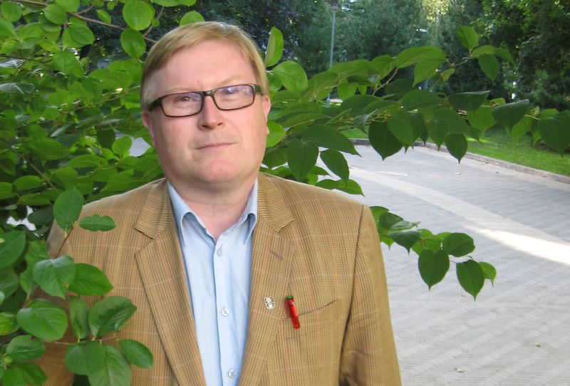**

**Kai Myrberg** is a physical oceanographer, leading scientist in the Finnish Environment Institute SYKE and also a visiting professor in oceanography at [Klaipeda University](http://translate.googleusercontent.com/translate_c?depth=1&hl=en&prev=search&rurl=translate.google.lv&sl=fi&u=http://fi.wikipedia.org/wiki/Klaipedan_yliopisto&usg=ALkJrhj9NkLrnFLPOxBa2ke7AiEZzC6WSg) since 2012. For 2015-2017 he is elected as vice-president of the International Council for Exploration of the Seas (ICES). His main field of interests has been physics of the Gulf of Finland. He has published more than 40 internationally peer-reviewed articles and five books. Together with prof. Matti Lepparanta he is the author of the first systematic monograph on the Baltic Sea oceanography “*Physical Oceanography of the Baltic Sea”.* Prof. Myrberg is also member of Baltic Earth network management team, previously known as BALTEX project. Since 2010 he has coordinated tri-lateral cooperation involving researchers and authorities from Finland, Estonia and Russia related to the protection of the marine environment. Prof. Myrberg’s activity has resulted as a project “Gulf of Finland Year 2014” which has been approved in all three countries at ministerial level. The Gulf of Finland-year study was divided into five themes, including political decision-making which requires more detailed research. The research themes were biological and geological diversity, ecosystem health, spatial planning, maritime safety, as well as fish and fisheries.

He is an editor on physical oceanography at *Boreal Environment Research* and member of board at *Geophysica*, *Estonian Journal of Earth Sciences*.

His keynote lecture “THE INTERNATIONAL GULF OF FINLAND YEAR 2014 -MAIN SCIENTIFIC FINDINGS “ will be on 18 June.

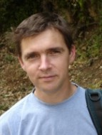

**Volker Mohrholz** is a physical oceanographer from Department of Physical Oceanography and Instrumentation at Leibniz-Institute for Baltic Sea research in Warnemünde, Germany. His areas of research include processes at the transition area between the North Sea and the Baltic, upwelling dynamics of the Benguela system, measuring of turbulence in coastal seas and fresh water dynamics at the coastal zone. He is a project manager for three running projects on African upwelling systems and prediction of tropic Atlantic climate. However, the saline water inflows from the North Sea into the Baltic has always been in Dr. Mohrholz’s range of interest and he has reported on those at Baltic Science Congresses since 2001. He is an author of more than 50 peer reviewed papers.

Dr. Mohrholz will have keynote lecture “FRESH OXYGEN FOR THE BALTIC SEA – THE MAJOR BALTIC INFLOW 2014” on 19 June.

**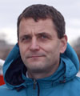**

**Henn Ojaveer** is a principal scientist in ecosystem dynamics at Estonian Marine Institute, University of Tartu. His academic interests involve research in distribution patterns and spatio-temporal dynamics of intermediate and upper trophic levels of the Baltic Sea as a result of climate and human activities; distribution and roles/impacts of non-indigenous species, and indicator-based assessment of marine ecosystems. He has served as a chair of the European Committee of the Census of Marine Life (EuroCoML) and ICES Strategic Initiative on Biodiversity Advice and Science (SIBAS). Currenlty, he is a chair ICES Working Group of Introductions and Transfers of Marine Organisms (WGITMO), and executive director of the global research initiative on Oceans Past. He is also a member to the ICES Science Committee (SCICOM). He is currently coordinator of the EU BONUS INSPIRE project and vice coordinator of the EU COST action on Oceans Past Platform (COST OPP). Has published >70 peer-reviewed papers.

Dr. Ojaveer will present a keynote lecture “AquaNIS IN ACTION: COMPREHENSIVE OVERVIEW ON THE NON-INDIGENOUS SPECIES INVASIONS AND THE VECTORS RESPONSIBLE IN THE BALTIC SEA” on 19 June.

**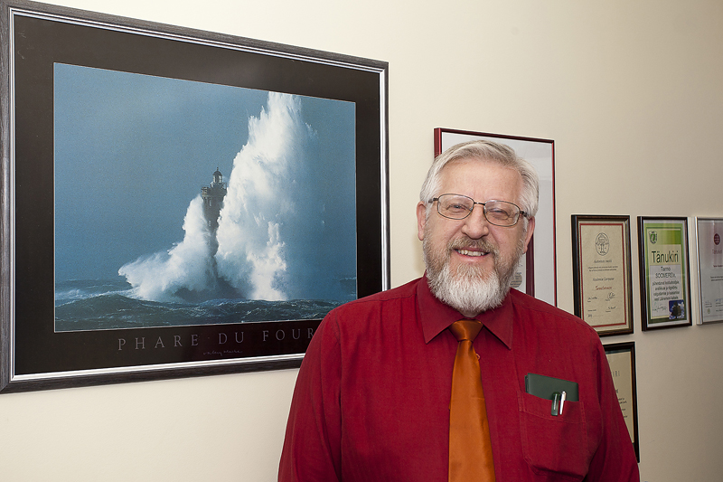**

**Tarmo Soomere** is a mathematician and marine scientist, the first Professor of Coastal Engineering in Estonia and one of the founders and of Estonian Centre of Excellence in Nonlinear Studies CENS. His scientific interests are mostly concentrated in wave matters, with applications in marine hazards to the coastal zone, and in preventive methods of coastal protection and coastal zone management. A highly unusual distinction for a scientist came from society: he was declared the Person of the Year in Estonia 2005 by daily newspaper *The Postman* for his contribution to the forecast of a devastating storm. He received twice the national science award (2002 and 2013) and the Baltic Assembly Prize for science in 2007, was elected to the Estonian Academy of Sciences in 2007 and to Academia Europaea in 2009, was nominated as Honorary Professor of the James Cook University (Australia) in 2010, received the title of the best communicator of science and technology in Estonia in 2011 and state decoration of 3rd class White Star order in 2014. Since December 2014 he is the President of the Estonian Academy of Sciences.

His keynote talk “SOCIETAL CHALLENGES IN MARINE SCIENCE” will be heard on 19 June as the final one.